**CHAPTER 3 DATABASE DEVELOPMENT**

**3.1 List of Tables**

In this project, tables involve including Branch, Cataloging, Inventory, Membership, Payment, Reservation, Staff, and Transaction.

Branch table is used to store the branches’ information which are BranchID, City, Telno, and StaffID. BranchID contains the ID of each branch. City is the city where the branch is located. Telno contains the phone number of each branch. StaffID is the ID of the staff who is managing the branch. Customers can easily locate and access the branch nearest to them with this information.

Cataloging table is used to store the details of each book. The details include the BookID, Title, Author, Category, Price, Pages, PubName, and PubYear. BookID contains the ID of each book. Title is the book’s title. Author is the author’s name of the book. Category specifies the category to which the book belongs such as Technology, Science, History, Business, etc. Price will be the price of each book in ringgit. Pages contains the number of pages of each book. PubName is the publisher’s name of each book. PubYear is the publication year of each book. This makes it easier for users to search for specific books and find relevant information quickly.

Inventory table stores the information in the inventory such as BookID, CopyAvail, and BranchID. BookID is the book ID that is available in each branch. CopyAvail is the number of book copies available in each branch. BranchID is the ID of each branch. This helps the staff to keep track of the quantity of each book available and their locations within the branches.

Membership table contains the details of each member such as MemberID, M_Name, Roles, DOB, and Gender. MemberID contains the ID of each member. M_Name is the name of each member. Roles are the role of each member such as librarian, administrator, and student. DOB stores the member’s date of birth. Gender is the sex of each member. PhoneNo refers to each member’s phone number, whereas Email refers to their email address. This allows the branches to keep track of their users and helps in managing memberships.

Payment table consists of the information of each payment for fines due to overdue. The information is PaymentID, MemberID, TransID, PaidAmount, and PaidDate. PaymentID is the ID of each payment. MemberID is the ID of the member who paid for the fines. TransID is the ID of the transaction to which the fines belong. PaidAmount is the amount paid by the member which should be the same as the fine amount. PaidDate is the date on which the member has paid the fines. This provides data for financial reporting and analysis, allowing the branches to assess revenue generated from fines, and track trends over time.

Reservation table stores the information of each member’s reservation, such as Res_ID, MemberID, BookID, Res_Date, For_Date, Res_Status, and TransID. Res_ID contains the ID of each reservation made. MemberID which is the ID of the member who made the reservation. BookID contains the ID of the reserved book. Res_Date is the date on which the member made the reservation. For_Date is the date when the member will collect the reserved book. Res_Status is the reservation status which shows that the reserved book has been reserved or borrowed by the member already. TransID is the ID of the transaction if the member borrows the book reserved. This allows the branches to keep track of reserved items and manage the reservation queue effectively.

Staff table contains the information of the staff which are librarians and administrators such as the StaffID which is the ID of the staff and MemberID which is the ID of the staff membership. This is important for security purposes and ensures that only authorized personnel can access sensitive information and library resources.

Transaction table consists of the details of the transactions made by each member such as TransID, BookID, MemberID, Duration, BorrowedDate, Renew, DueDate, ReturnDate, Overdue, Fine and Paid. TransID is the ID of each transaction made by each member. BookID is the ID of the book involved in each transaction. MemberID is the ID of the member who made the transaction. Duration contains the number of days the book can be borrowed which are 7 days if no renewal and 14 days if there is renewal. BorrowedDate contains the date on which the book is borrowed. Renew stores the choice of whether the member wants to extend the borrowing period. DueDate is the deadline for the member to return the book borrowed. ReturnDate is the date on which the member return the book borrowed. Overdue is the days past the due date that an item remains unreturned. Fine is the amount of fine that members need to pay due to overdue. Paid is used to record whether the member has paid the overdue fine. The information is useful for keeping the library's operations accountable and transparent overall, tracking the flow of books, processing fines for overdue books, recording transactions for borrowing and returning, and managing reservations.

**3.1.1 Data Dictionary and Table Records**

1. Branch

*Figure 3.1.1.1 Branch Data dictionary*

*Table 3.1.1.1 Branch Table records*

1. Cataloging

*Figure 3.1.1.2 Cataloging Data dictionary*

*Table 3.1.1.2 Cataloging Table records*

1. Inventory

*Figure 3.1.1.3 Inventory Data dictionary*

*Table 3.1.1.3 Inventory Table records*

1. Membership

*Figure 3.1.1.4 Membership Data dictionary*

*Table 3.1.1.4 Membership Table records*

1. Payment

*Figure 3.1.1.5 Payment Data dictionary*

*Table 3.1.1.5 Payment Table records*

1. Reservation

*Figure 3.1.1.6 Reservation Data dictionary*

*Table 3.1.1.6 Reservation Table records*

1. Staff

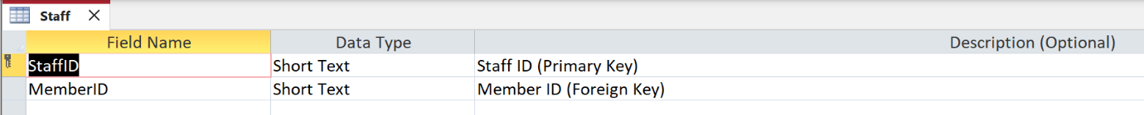

*Figure 3.1.1.7 Staff Data dictionary*

*Table 3.1.1.7 Staff Table records*

1. Transaction

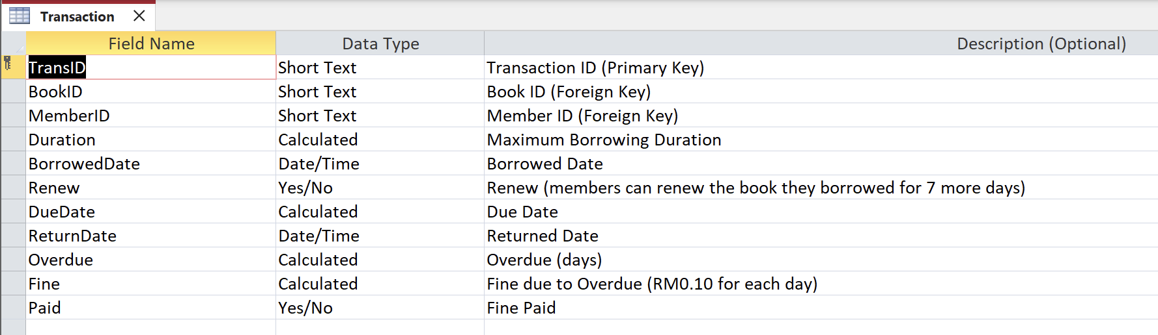

*Figure 3.1.1.8 Transaction Data dictionary*

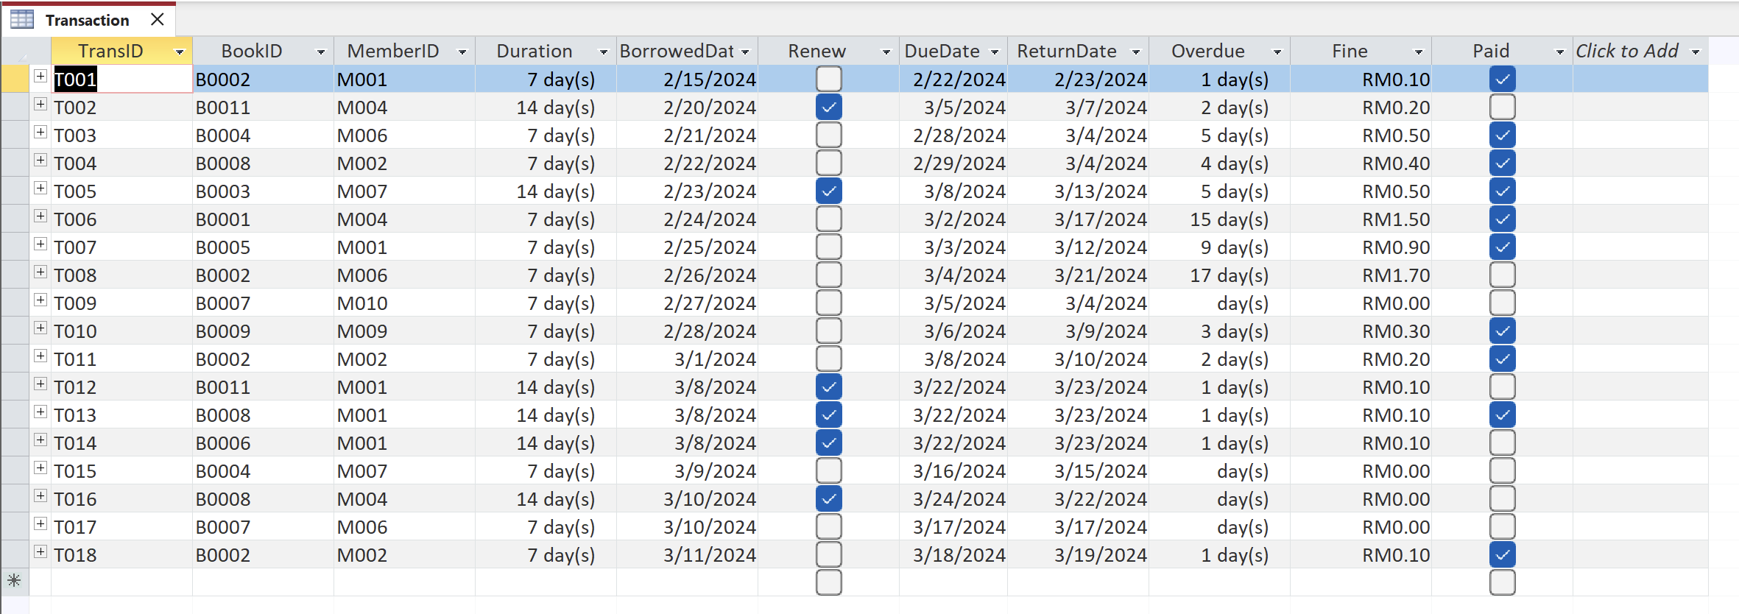

*Table 3.1.1.8 Transaction Table records*

**3.2 Switchboard**

Switchboard in Microsoft Access is a form that lets users move around in an Access database. There are clickable buttons on the switchboard. These buttons can be configured by the user to open queries, reports, forms, etc. In our study, we have included a membership section that allows users to add and edit the information of the membership. Also, the book borrowing form and payment form buttons are provided to navigate the users to the specific form to add and edit the details. The view report for the three reports, which are the inventory for each category report, book borrowed report, and overdue fined report buttons allows the users to read the report.

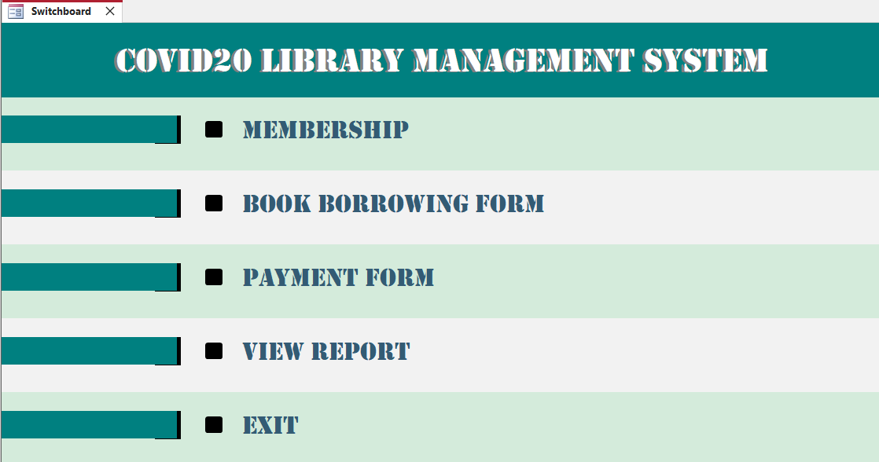

*Figure 3.2.1 Switchboard*

*Figure 3.2.1.1 Membership Section in Switchboard*

*Figure 3.2.1.2 Book Borrowing Form Section in Switchboard*

*Figure 3.2.1.3 Payment Form Section in Switchboard*

*Figure 3.2.1.4 View Report Section in Switchboard*

**CHAPTER 4 DATABASE OBJECTS**

**Database Objects**

Database object is any defined object that is used to store or reference data in a database. The main objects are tables, forms, queries and reports. These objects let users enter, save, analyse, and compile data in a variety of ways.

**4.1 Queries**

Queries are used for multiple purposes such as providing users an answer to a simple question, performing calculations, combining data from different tables, add, change, or delete data from a database. There are 3 queries created in this project which are Book Reserved Record query, Member Fines Record query, and Overdue Books Record query.

**4.1.1 Query 1**

Command:

SELECT Membership.MemberID, Membership.M_Name, Membership.Roles, Transaction.TransID, Transaction.Fine

FROM Membership INNER JOIN [Transaction] ON Membership.MemberID = Transaction.MemberID

WHERE (((Membership.M_Name)="Allice"));

Explanation: The Member Fines Record query is used to track all the fines imposed on a student named Allice. The fields used are MemberID, M_Name, and Roles from Membership table and TransID and Fine from Transaction table. The criteria set for M_Name is “Allice”.

Sample query 1:

*Table 4.1.1 Member Fines Record query*

**4.1.2 Query 2**

Command:

SELECT Cataloging.BookID, Cataloging.Title, Membership.*, Transaction.Overdue

FROM Membership INNER JOIN (Cataloging INNER JOIN [Transaction] ON Cataloging.BookID = Transaction.BookID) ON Membership.MemberID = Transaction.MemberID

WHERE (((Transaction.Overdue)=True));

Explanation: The Overdue Books Record query is used to track overdue books with the user information. The fields used are BookID and Title from Cataloging table, all the fields in Membership table , and Overdue from Transaction. The criteria set for Overdue is True.

Sample query 2:

*Table 4.1.2 Overdue Books Record query*

**4.1.3 Query 3**

Command:

SELECT Cataloging.BookID, Cataloging.Title, Reservation.Res_ID, Reservation.Res_Status

FROM Cataloging INNER JOIN Reservation ON Cataloging.BookID = Reservation.BookID

WHERE (((Reservation.Res_Status)="Reserved"));

Explanation: The Book Reserved Record query is used to track books with reservation status. The fields used are BookID and Title from Cataloging table and Res_ID and Res_Status from Reservation table. The criteria set for Res_Status is “Reserved”.

Sample query 3:

*Table 4.1.3 Book Reserved Record query*

**4.2 Forms**

Forms is a database object that allows a user to create a database application's user interface by using this Access form.

**4.2.1 Form 1**

Explanation: This membership registration form enables staff, administrators, and students without membership to join the library. This form requires the user to enter their name, role, date of birth, gender, phone number, and email address. The memberID will be assigned by the librarian or admin of the library.

Sample form 1:

*Figure 4.2.1 Membership Registration Form*

**4.2.2 Form 2**

Explanation: A book borrowing form is one that the librarian uses to complete the information of the patron who has checked out books from the library. The dates of the reservation and collection of the member-borrowed book were recorded on this form.

Sample form 2:

*Figure 4.2.2 Book Borrowing Form*

**4.2.3 Form 3**

Explanation: This payment form enables the COVID20 Library administrator to document the member's payment of past-due penalties. The payment amount, payment date, memberID, transID, and paymentID are all included in this form.

Sample form 3:

*Figure 4.2.3 Payment Form*

**4.3 Report**

Reports in Microsoft Access are useful tools for presenting and summarising data from the database. It enables you to organize and format data in a visually appealing manner, making it easier to comprehend and analyze.

**4.3.1 Report 1**

Explanation: The available copies of each category are displayed in the inventory for each category report, which is sorted by bookID across several branches. The user can view and read the total number of copies that are available by category with this report.

Sample report 1:

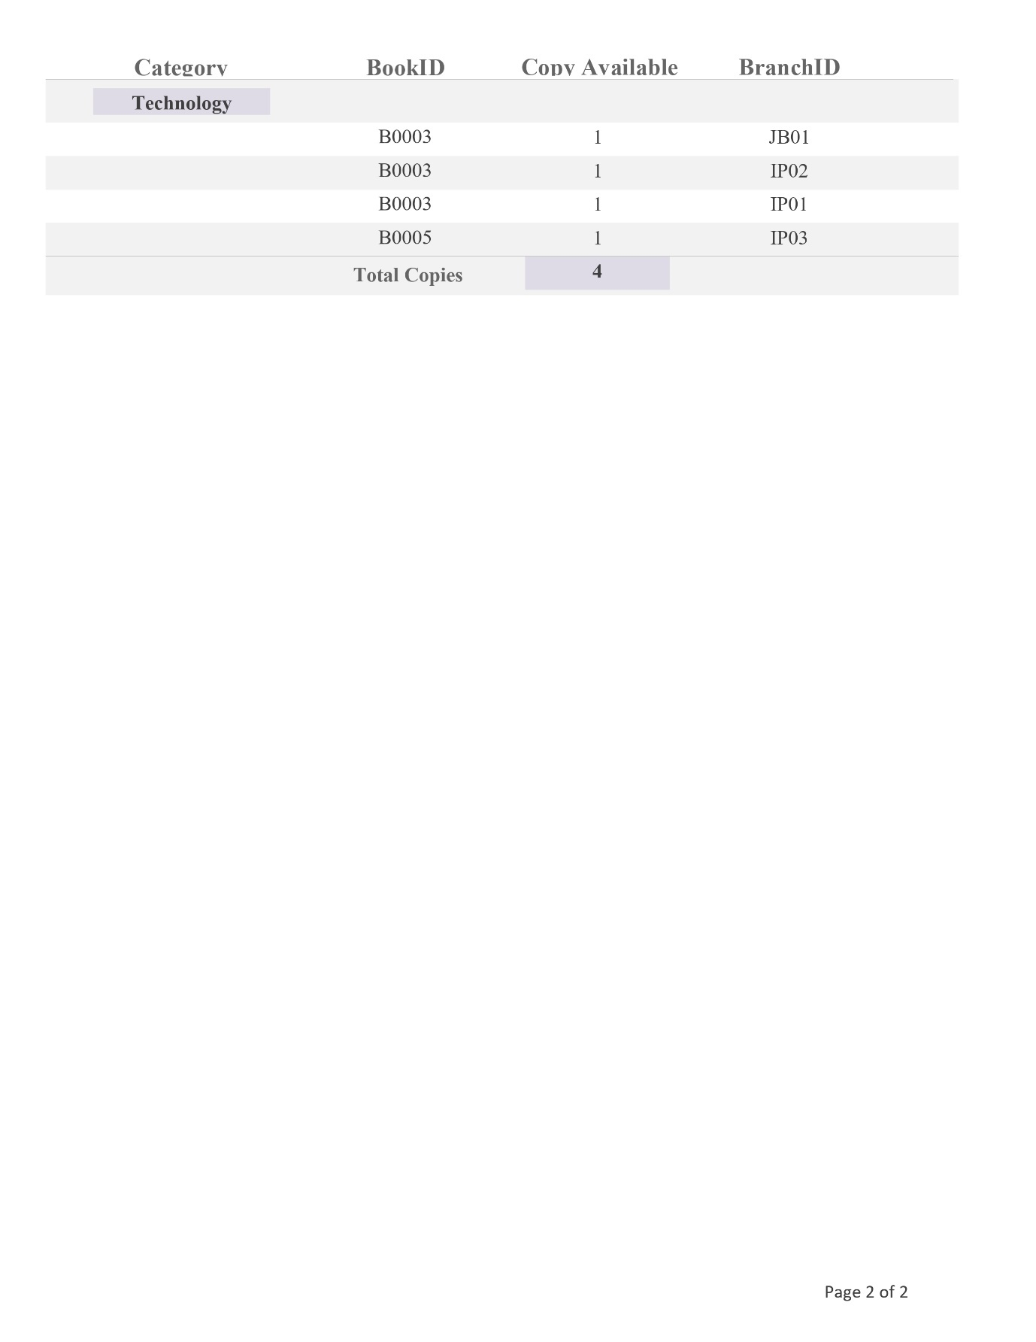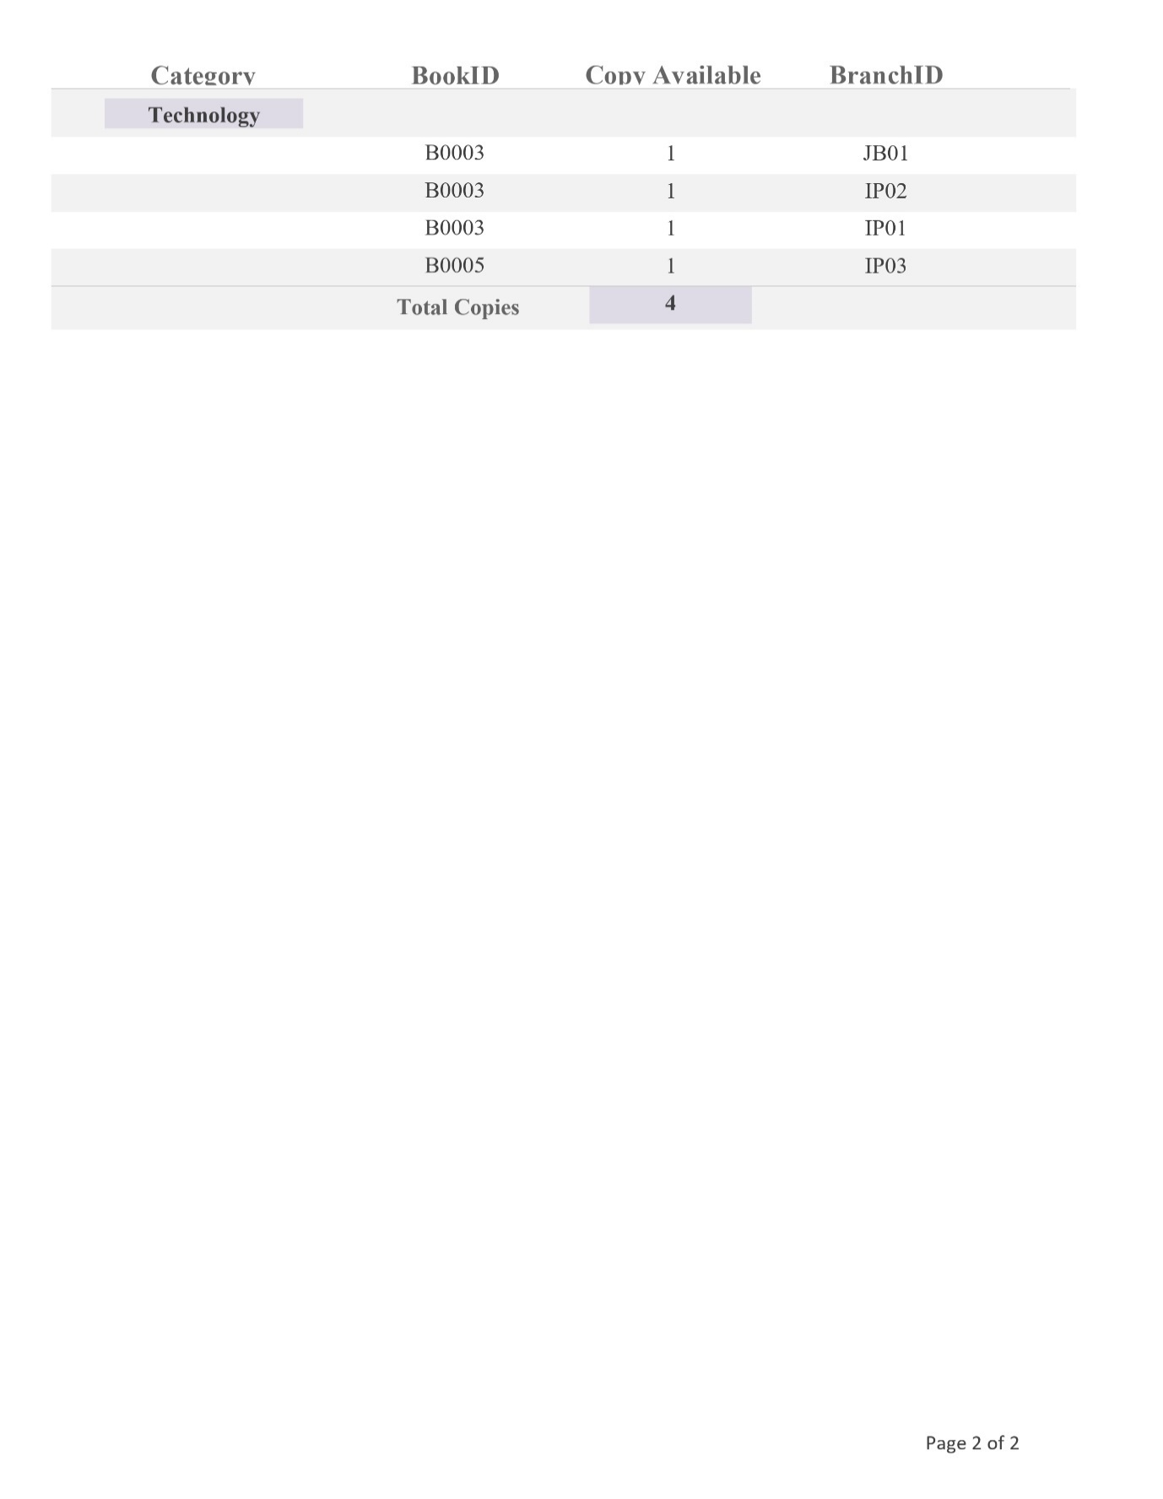

*Figure 4.3.1 Inventory for Each Category Report*

**4.3.2 Report 2**

Explanation: This report shows the total number of books borrowed by each student broken down by month. This report provides a precise breakdown of the number of books borrowed by members in February and March.

Sample report 2:

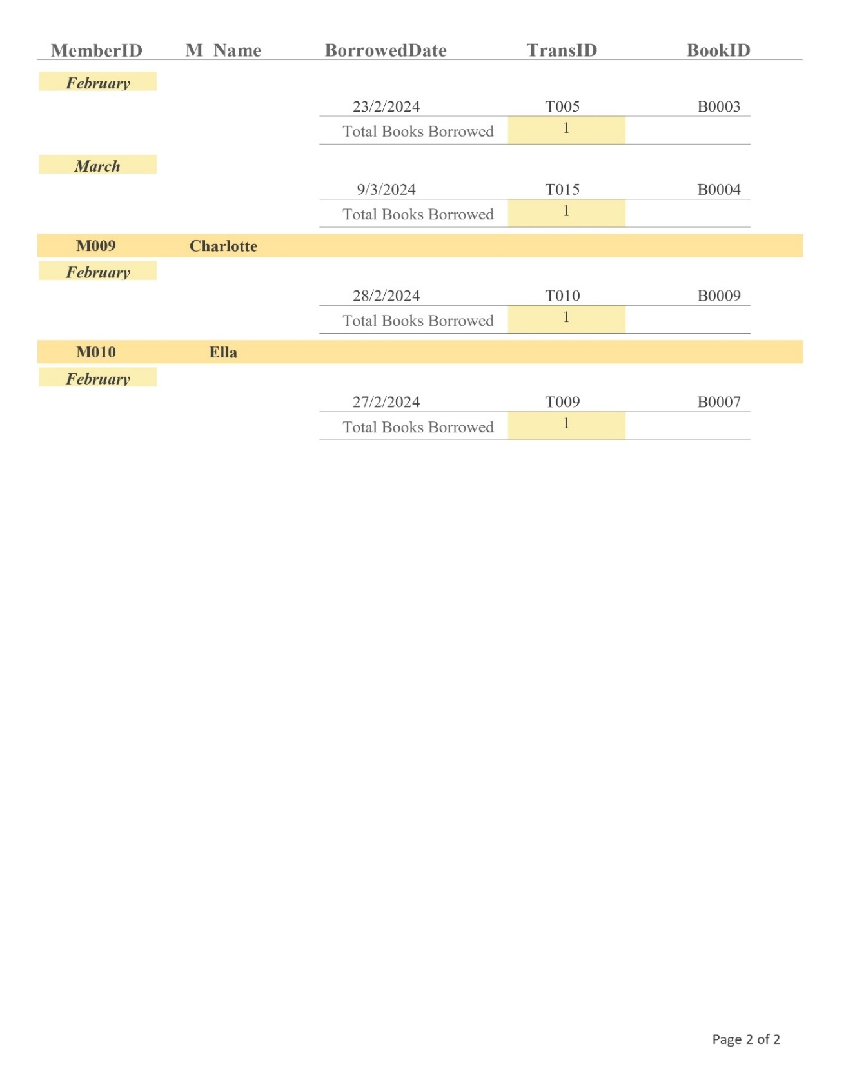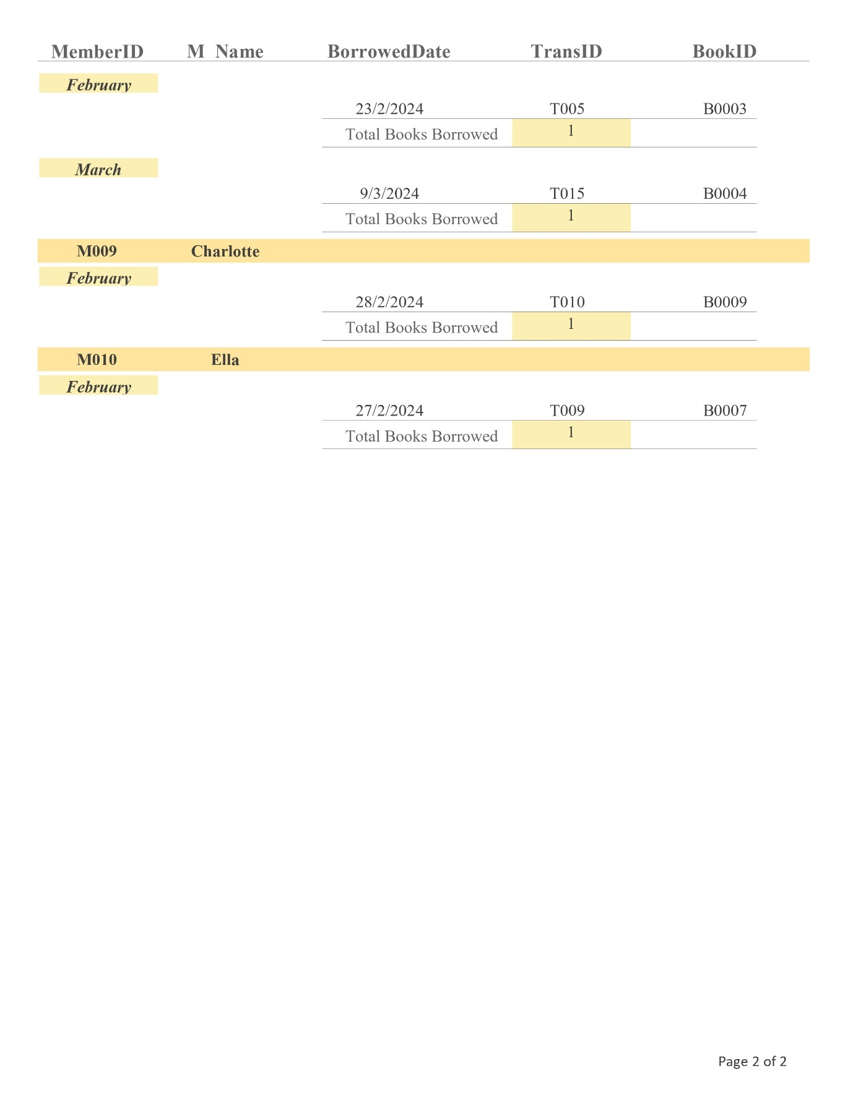

*Figure 4.3.2 Total Book Borrowing According to Month Report*

**4.3.3 Report 3**

Explanation: The list of members who haven't paid their past-due book fine is displayed in the overdue fine report. From this report, we can see the total number of books that a member has fined but hasn't paid.

Sample report 3:

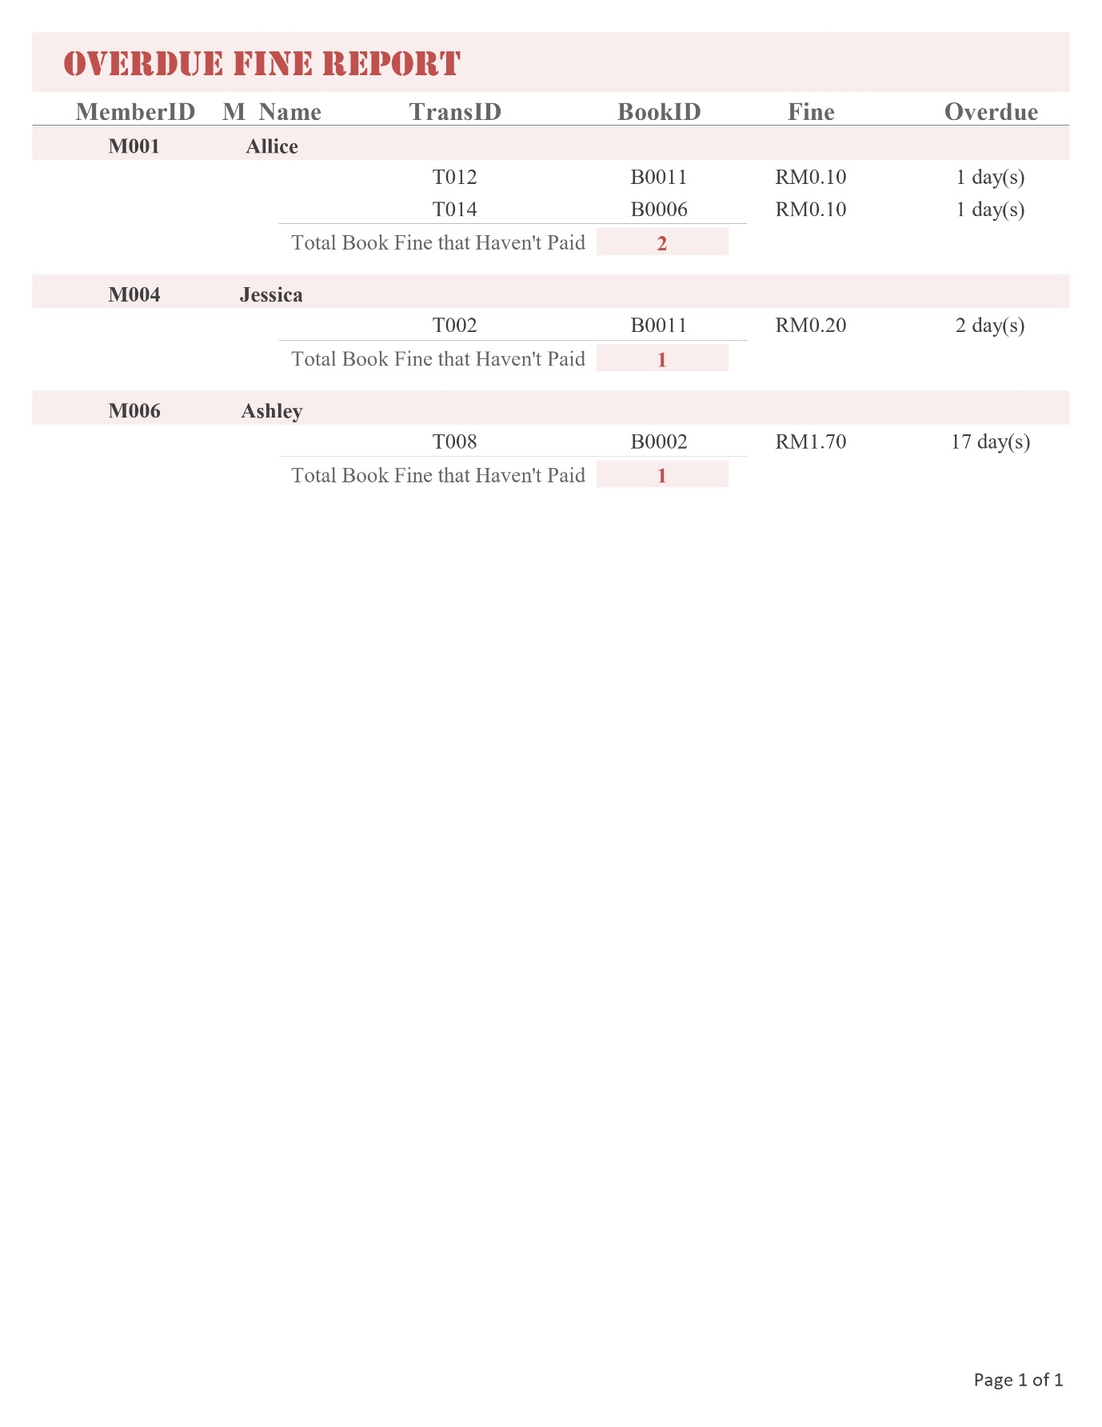

*Figure 4.3.3 Overdue Fine Report*